**Observation of robust magnetic order in monolayer NiPS3**

Lili Hu1†, Hao-Xin Wang4†, Yuzhong Chen1, Kang Xu2, Ming-Rui Li4, Haiyun Liu1, Peng Gu1, Ke Wu3, Yubin Wang2, Mengdi Zhang1, Hong Yao2,4*, Qihua Xiong2,1*

1 *Beijing Academy of Quantum Information Sciences, Beijing 100193, P.R. China*

2 *State Key Laboratory of Low-Dimensional Quantum Physics and Department of Physics, Tsinghua University, Beijing 100084, P.R. China*

3 *School of Physics and Technology and Key Laboratory of Artificial Micro- and Nano-structures of Ministry of Education, Wuhan University, Wuhan 430072, China*

4 *Institute for Advanced Study, Tsinghua University, Beijing, China*

* Corresponding author. Email: qihua_xiong@mail.tsinghua.edu.cn

yaohong@tsinghua.edu.cn

† These authors contributed equally to this work.

**Abstract**

Monolayer ferromagnet and antiferromagnet of XY-type compose a pivotal part of the two-dimensional magnetism, which has become one of the new frontiers in two-dimensional materials. Because of the zero net magnetic moment and large spin fluctuation, the confirmation and investigation of monolayer XY-type antiferromagnet confront ambiguity occasionally and becomes an intriguing issue. As an important XY-type antiferromagnet and Berezinskii-Kosterlitz-Thouless (BKT) transition candidate, whether monolayer NiPS3 has magnetic order is still controversial. Herein we have investigated the helicity-resolved Raman and ultrafast spectroscopy of NiPS3 from bulk to monolayer samples. By analyzing the intrinsic two-magnon properties and ultrafast transient absorptions, we find that monolayer NiPS3 is magnetically ordered at low temperatures with a possible BKT-transition at *T*BKT = 140 K. We have also performed density matrix renormalization group (DMRG) calculation to verify the zigzag-AFM magnetic ground state and Monte-Carlo simulations to verify BKT-transition in monolayer NiPS3. The theoretically obtained transition temperature *T*BKT of monolayer NiPS3 agrees well with our experimental data. Our research establishes monolayer NiPS3 as an ordered XY-type antiferromagnet with possible BKT transition, consisting of an important platform for investigating complex couplings and topological excitations in two-dimensional magnetic materials.

Two-dimensional materials have provided an important platform for fundamental physics and unprecedented device functionalities, driven by new degree of freedoms of various elemental excitations in the two-dimensional (2D) limit resulted from peculiar confinement behaviors and strong interactions1. Recently, considerable progress has been made in the emergent two-dimensional magnetic materials2,3. According to the Mermin-Wagner theorem, long-range ferromagnetism (FM) and antiferromagnetism (AFM) in two-dimension with continuous global symmetry are expected to be forbidden at finite temperatures4. However, the single-ion anisotropy caused by spin-orbit coupling and the interaction between adjacent layers facilitates the realization of two-dimensional long-range magnetic orders. A variety of two-dimensional magnetic materials have been experimentally verified recently, most of which are of Ising type5,6 or Heisenberg type7,8. In addition, it is theoretically proved that there may exist a special topological BKT transition at finite temperatures in an XY-like two-dimensional system, hallmarked by the transition of bound vortice-antivortice pairs into free vortices9. The BKT-phase transition is found to have a tight correlation with superfluidity10, Bose-Einstein condensation11, and superconductivity12. Only in material systems fitted with XY (or XXZ-model with weak interlayer interaction), BKT-transition is possible to be observed experimentally.

Recently, important progress in many-body exciton13, magnon-phonon coupling14, and magnon-based device15 has been made in the field of 2D antiferromagnetic materials. The intralayer antiferromagnetic *M*P*X*3 (*M* = Fe, Ni, Mn, and *X* = S, Se) family has attracted much attention due to their (quasi)2D antiferromagnetism, rich spin dimensionalities, strong coupling between multi-degrees of freedom, and potential applications in quantum information technology16,17. With varying transition metal *M* atoms among Fe, Ni, and Mn, the magnetism in *M*P*X*3 behaves as Ising-type (FePS3), XY-type (NiPS3), and Heisenberg-type (MnPS3). While the bulk *M*P*X*3 exhibit the *C*2*h* point group symmetry, the point group of the monolayer is *D*3*d*. NiPS3 inherits the lattice structure of *M*P*X*3 family, where intralayer Ni2+ ions form a honeycomb lattice18,19, as schematically shown in Fig. 1a. Each Ni2+ has a magnetic moment of 3μB (Bohr magneton). The Ni2+ ions with the same spin direction form the zigzag FM chains parallel to the *a*-axis and the FM chains are coupled in an AFM manner. At about 150 K, NiPS3 undergoes a phase transition from zigzag-AFM to PM (paramagnetism). The temperature dependence of phonon splitting and linear dichroism suggested that zigzag-AFM exists only within the thickness ranging from bulk to bilayer, with the monolayer found magnetically disordered due to enhanced spin fluctuation20,21. Note that the phonon splitting due to symmetry lowering from *D*3d to *C*2h by zigzag-AFM order has been observed in monolayer CoPS3, a sister compound of monolayer NiPS3, making the magnetic phase of monolayer NiPS3 more intriguing22. Meanwhile, theoretical studies have suggested that there exists a magnetic order in the monolayer NiPS323,24. Even it is highly suspected that BKT-transition exists in monolayer NiPS3, no phase transition has been detected experimentally till now. Whether there is a magnetic order in the monolayer NiPS3 and how to detect this ordering has become an urgent problem in the field of two-dimensional magnetic materials. In addition, NiPS3 has been regarded as a platform to study the intertwining physical phenomenon between magnetism and other degrees of freedom, which has not been fully understood21. Especially a spin-coupled coherent exciton has been observed in NiPS3 system which is very unusual for magnetic materials11,19,25. To clarify the physical mechanism underlying the spin-coupled behaviors of charge, lattice, exciton, and magnon in two-dimensional limit towards rational manipulating these couplings, the experimental determination of magnetic order for NiPS3 monolayer is demanded. Here we report the experimental observation of robust magnetic order in monolayer NiPS3. This conclusion is supported by results of helicity-resolved Raman and ultrafast spectroscopy, and assisted by theoretical calculations. All our experimental observations and theoretical calculations support the magnetic phase transition at ~140 K for monolayer NiPS3.

Figure 1a shows the schematic lattice structure and the magnetic order of a single layer NiPS3. The upper panel of Fig. 1b shows the optical images of monolayer and bilayer NiPS3 on Si/SiO2 substrates, prepared by mechanical exfoliation methods (see details in Methods), for the purpose of helicity-resolved Raman spectroscopy measurements26. The three lower panels of Fig. 1b are the optical images of monolayer, bilayer, and thin bulk samples on transparent substrates (SiO2 for monolayer, and sapphire for bilayer and thin bulk) used for the ultrafast spectroscopy experiments. The AFM cross section traces are presented in Fig. 1b to characterize the sample thickness. The helicity-resolved Raman spectra of single crystal and monolayer NiPS3 at 30 K are shown in Fig. 1c and 1d, with the corresponding polarization configurations annotated at the right top corner of each panel, in which XX (XY) represents co- (cross-) linear polarization and σ+σ+ (σ+σ-) represent co- (cross-) circular polarization configurations, respectively. The main phonon peaks are assigned in spectra under σ+σ- and σ+σ+ polarizations to cover all the phonon peaks observed. As can be seen from Fig. 1c and 1d, according to the polarization dependence observed, all the phonon peaks can be understood based on *D*3d symmetry (the Raman tensor analysis of the *D*3d point group can be found in Supporting Information), which is in good agreement with previous literatures, implying a weak interlayer interaction in the NiPS3 system27 and accordance with 2D-XY-model. With the *D*3d point group, the Raman active modes can be divided into *A*g (out-of-plane vibration) and *E*g (in-plane vibration) modes28. When considering the weak interlayer interaction and symmetry lowering by zigzag-AFM order, the *E*g modes split into *A* and *B* modes, resulting in the frequency splitting of $E_{g}^{1}$ under different linear polarizations (XX and XY) as denoted by the dashed lines in Fig. 1c. Note that the frequency splitting of specific $E_{g}^{1}$ phonon peak at around 175 cm-1 was utilized as a criterion to determine the existence of zigzag-AFM order in NiPS3 in previous report20. Other than the narrow phonon peaks, there is a broad continuum scattering in Raman spectra as shown in Fig. 1c and 1d, which is identified to be two-magnon scattering (denoted as 2M mode) 20,29. The 2M signal is highlighted by a red shadow, resulted from a composite lineshape analysis. It can be seen from Fig. 1c and 1d that the 2M band only appears in XX, XY, and σ+σ- polarizations, while the scattering intensity under the σ+σ- is around twice of that under the XY polarization, indicating that the 2M modes belong to the *E*g representation of *D*3d point group (see Supporting Information for detailed analysis).

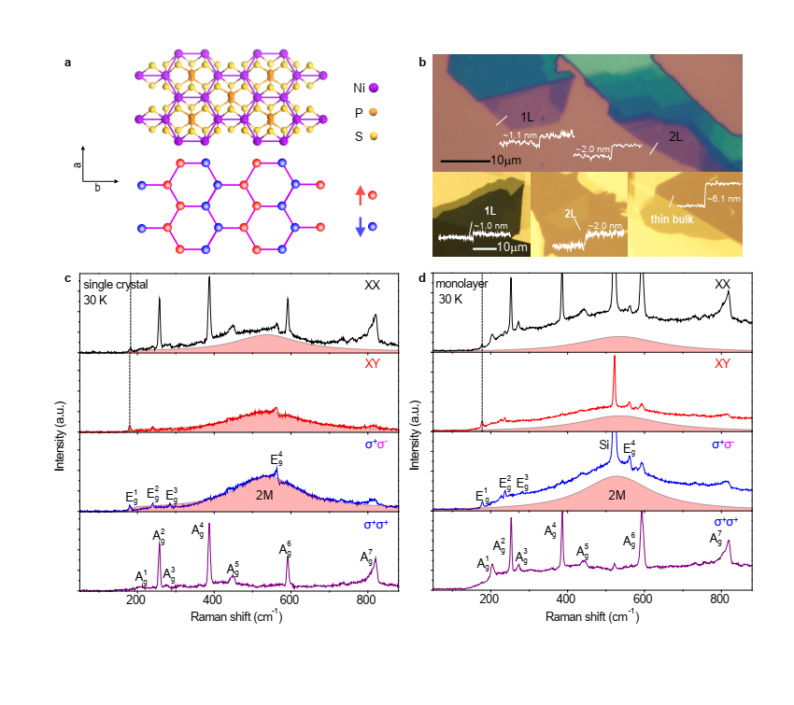

**Fig. 1 | The NiPS3 samples and helicity resolved Raman spectra.** **a,** Lattice and magnetic structure of a single-layer NiPS3. **b,** Optical photographs of monolayer and bilayer NiPS3 for helicity-resolved Raman spectroscopy and monolayer, bilayer and thin bulk NiPS3 for ultrafast spectroscopy. The height of the samples is indicated by the AFM cross section traces. **c and d,** Helicity-resolved Raman of single crystal and monolayer at 30 K.

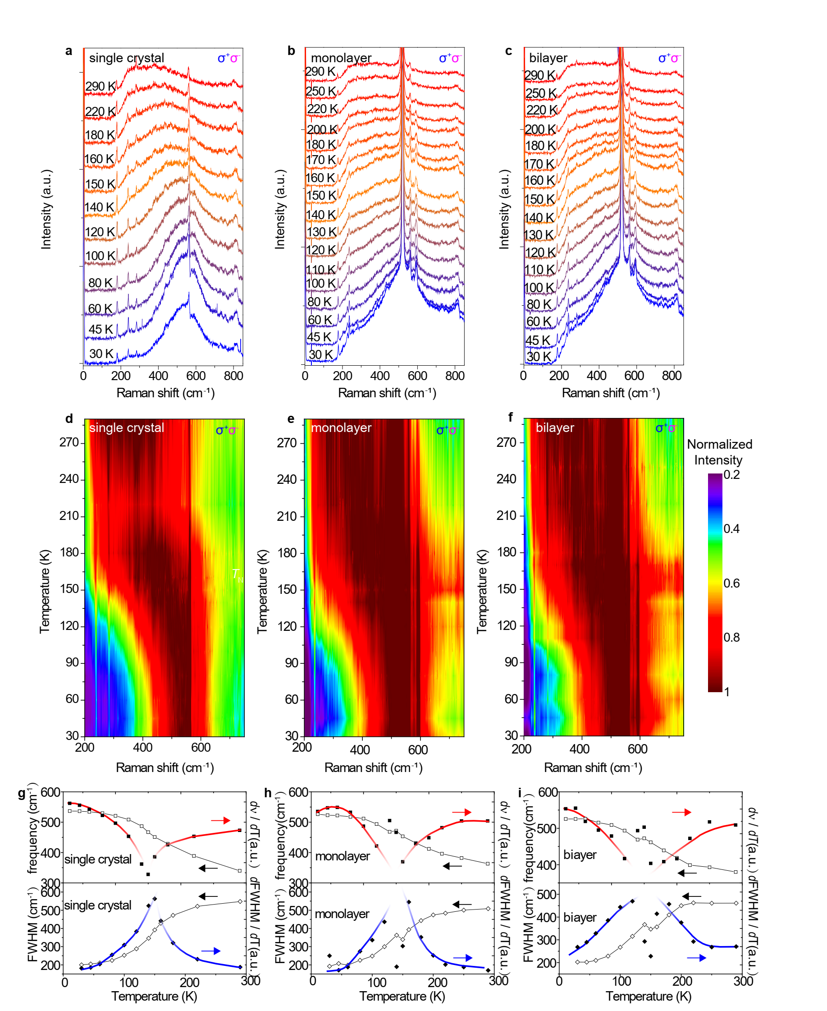

**Fig. 2 | Temperature-dependent Raman spectra of single crystal NiPS3 at σ+σ- polarization. a,** **b, and c,** Temperature-dependent Raman spectra of single crystal, monolayer, and bilayer NiPS3. **d,** **e, and f,** Colormaps of normalized Raman spectra at σ+σ- polarization for single crystal, monolayer, and bilayer NiPS3. **g-i**, Temperature dependence of frequency (ν), FWHM, *d*ν/*d*T, and *d*FWHM/*d*T for single crystal, monolayer and bilayer at σ+σ- polarization.

Because the 2M band has overwhelming intensity and a better signal-to-noise ratio under the σ+σ- polarization, the 2M properties are mainly analyzed from Raman spectra at σ+σ- polarization. Temperature-dependent Raman spectra of single crystals, monolayer, and bilayer (offset vertically for clarity) are shown in Fig. 2a, 2b, and 2c respectively. As the temperature increases from 30 K to 290 K, the 2M band broadens and redshifts remarkably. Although the intensity decreases as temperature increases, the 2M band is still prominent even at 290 K. Across all the temperatures, the intensity at σ+σ- polarization keeps almost twice of that at XY polarization, obeying well to the *D*3d symmetry thus suggesting that in the whole temperature range the quasi-2D property of 2M can be maintained (see Supporting Information). To further elaborate the temperature evolution of 2M bands, we normalize the Raman spectra to the maximum of 2M band ($I_{2M}^{max}$) under σ+σ- polarization, and plot the normalized Raman spectra into colormap graphs, as shown in Fig. 2d, 2e and 2f. From the colormaps, we can see that the frequency (ν) and full width at half-maximum (FWHM) of 2M bands all show abrupt changes at *T* ≈ 150 K for single crystal, monolayer, and bilayer. The values of frequency and FWHM can be obtained by fitting the 2M band with Lorentzian lineshape. It is well known that the Néel temperature *T*N ≈ 150 K for bulk NiPS3 corresponds to AFM-PM phase transition21,23. Thus the 2M properties indicate a magnetic phase transition for the NiPS3 system of different thicknesses at ~150 K. We plot frequency and FWHM of 2M with temperatures in Fig. 2g-2i to quantitatively analyze the temperature-dependence of 2M properties, especially the remarkable change at magnetic phase transition temperature. The frequency and FWHM are shown by the open squares and open diamonds in Fig. 2g-2i. We also obtain first order derivatives of frequency and FWHM versus temperature for single crystal, monolayer, and bilayer as shown by the solid squares and solid diamonds in Fig. 2g-2i, while the red and blue curves are guides for the eyes. The emergence of singularity points of *d*ν/*d*T and *d*FWHM/*d*T at ~140 K for monolayer strongly suggest that the monolayer NiPS3 sample has robust magnetic ordering at low temperature.

We then investigate the transient absorption spectra of the monolayer, bilayer, and thin bulk NiPS3 samples at variable temperatures, pumped by a 385 nm femtosecond laser pulse (see Methods for details). Figure 3a shows the steady-state absorption spectra of monolayer and thin bulk samples at 60 K and 240 K, respectively. The centers of the absorption peaks are about 570 nm and 560 nm for thin bulk and monolayer samples respectively, with a slight redshift with the increase of temperature. The wavelength chosen for analyzing the magnitude of the time-resolved ΔT/T is 532 nm to keep consistent with the Raman excitation wavelength (for other probe wavelengths, see Supporting Information). Figure 3b shows the temperature-dependent ultrafast dynamics of monolayer NiPS3 from 60 K to 240 K, offset vertically for clarity. The colormap by plotting ΔT/T versus the time delays and the temperatures (60-240 K) are displayed in Fig. 3c-3e for monolayer, bilayer, and thin bulk samples respectively. As shown in Fig. 3c and 3d, for the monolayer and bilayer samples, the overall variation tendency of ΔT/T is decreasing with the increase of temperatures, but there is a local maximum near 150 K 30,31, which indicates that the phase transitions of monolayer and bilayer NiPS3 occurring at about 150 K. For the thin bulk sample as shown in Fig. 3e, the change of the color scale in 120 K -170 K is less sensitive to indicate the phase transition. We further extract the (ΔT/T)max of monolayer, bilayer, and thin bulk samples to plot versus the temperature, as shown in Fig. 3f, vertically offset for clarity (the offset values are 5×10-3 for bilayer and 1×10-2 for monolayer). It can be seen that a plateau-like region of (ΔT/T)max appears at about 150 K for all samples, signifying the magnetic phase transition for monolayer, bilayer, and thin bulk samples, in accordance with the results of helicity-resolved Raman spectroscopy results. The transition temperatures extracted from Fig. 3f are 160 K for bulk, 150 K for bilayer and 140 K for monolayer. Since NiPS3 is of XY-type, with the thinning of the layers, it is likely that the phase transition changes from AFM-PM transition for the bulk to BKT-transition for the monolayer.

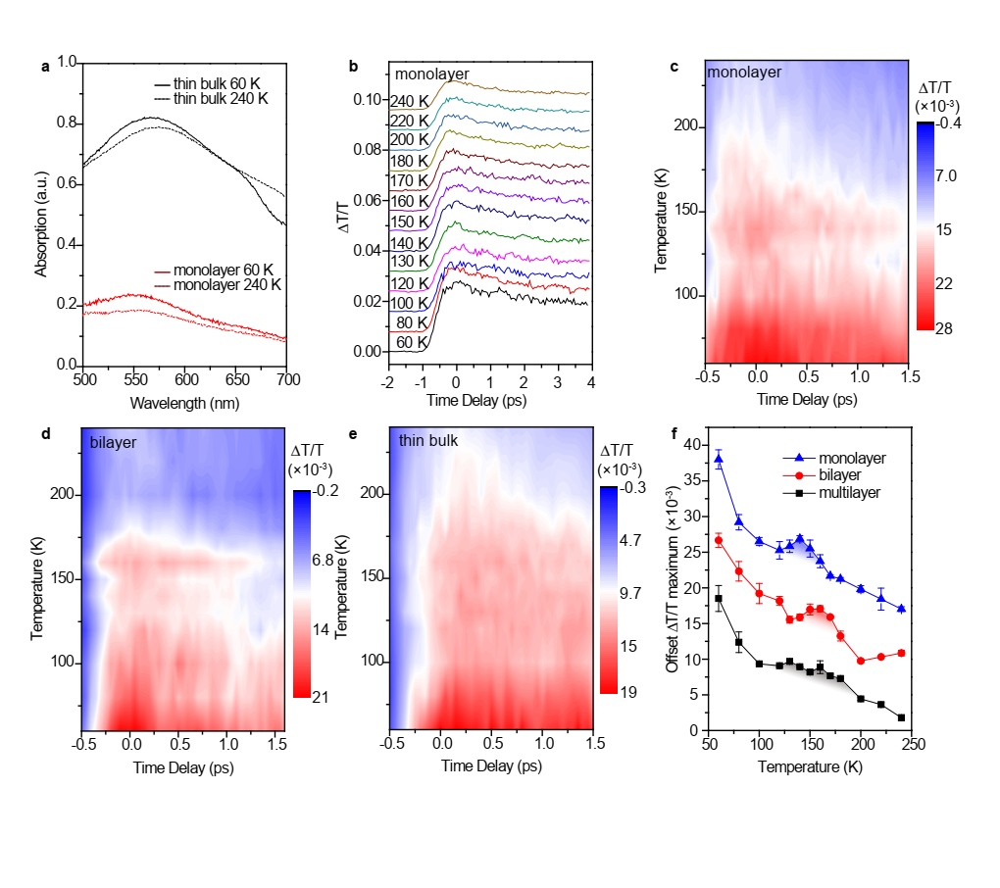

**Fig. 3 | Ultrafast spectroscopy investigation of NiPS3. a,** The steady state absorption spectra of monolayer and thin bulk at 60 K and 240 K. **b,** The temperature-dependent ultrafast dynamics of monolayer NiPS3. **c, d, and e,** The colormap of time-resolved ΔT/T for monolayer, bilayer, and thin bulk NiPS3. **f,** The temperature dependent of (ΔT/T)max for monolayer, bilayer, and thin bulk.

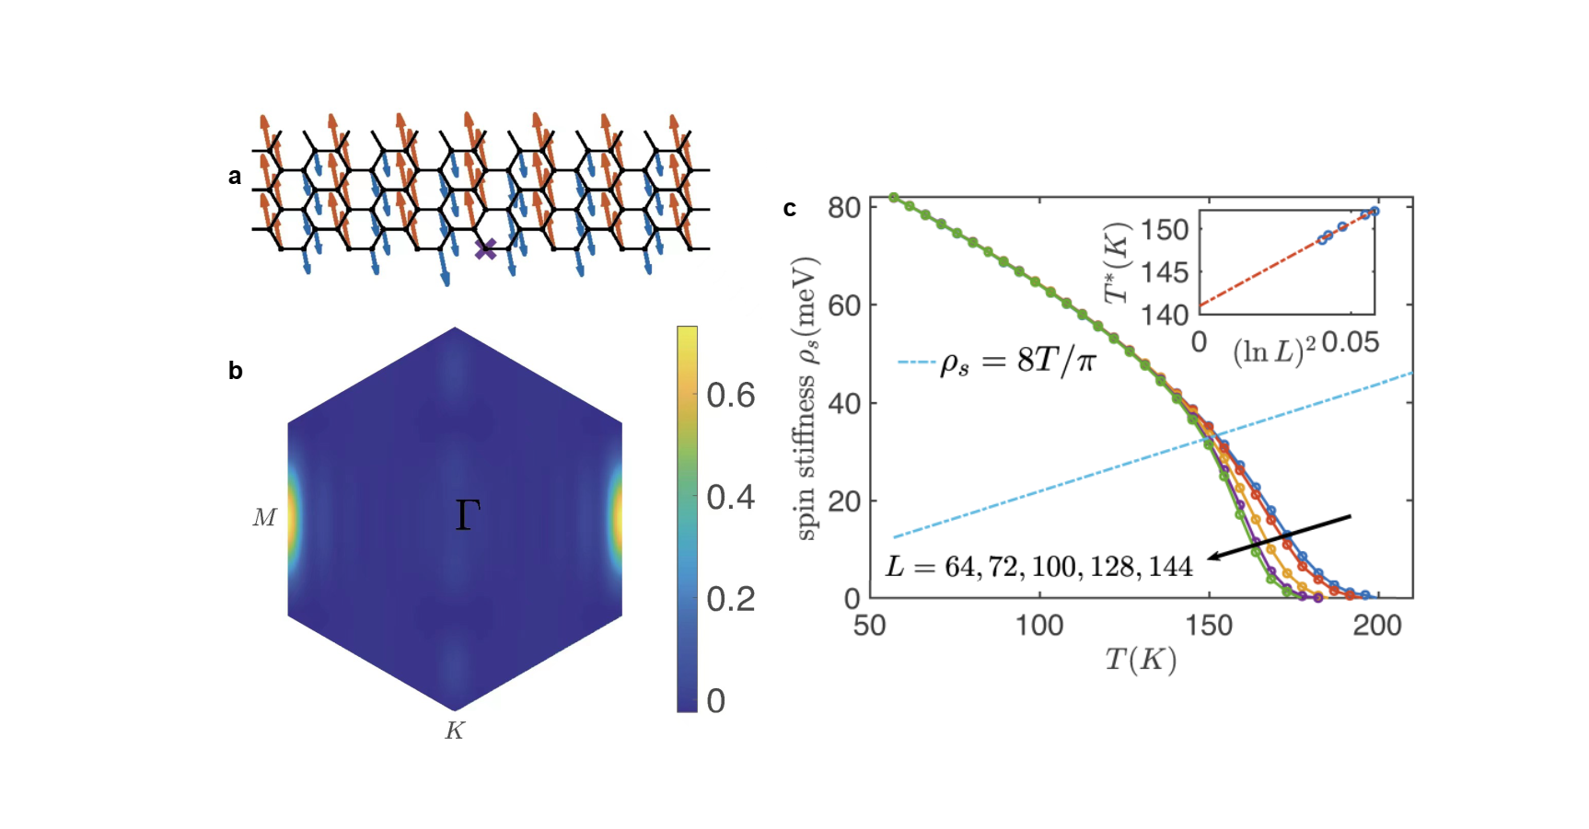

**Fig. 4 | Magnetic ground state and BKT transitions in monolayer NiPS3.** **a,** in-plane spin correlations. **b,** sublattice spin structure factor for the ground state of the J1-J2-J3-D model, calculated by DMRG. **c,** Temperature dependence of the Monte-Carlo-computed spin stiffness $ρ_{s}(L)$ at different linear size $L$.

To gain insight of the low temperature magnetic phase, and the corresponding phase transition, we further performed theoretical calculations in monolayer by determining the ground state at zero temperature, and evaluating the phase transition temperature. We consider a minimal effective spin-1 model including dominating spin-exchange coupling and single-ion anisotropy (SIA) which can be written as

$$H=J_{1}\sum_{⟨i, j⟩}{S_{i}⋅S_{j}}+J_{2}\sum_{⟨⟨i, j⟩⟩}{S_{i}⋅S_{j}}+J_{3}\sum_{⟨⟨⟨i, j⟩⟩⟩}{S_{i}⋅S_{j}}+D_{zz}\sum_{i}{{\left(S_{i}^{z}\right)}^{2} },$$

where $\left\langle i, j\right\rangle$, $\left\langle \left\langle i, j\right\rangle \right\rangle$ and $⟨⟨⟨i, j⟩⟩⟩$ represent the nearest, the next-nearest, and the third-nearest neighbor (NN, NNN, and TNN) sites $i$ and $j$, respectively. adoptaccording tocalculations24

According to the Mermin-Wagner theorem, a 2-dimensional model with U(1) symmetry forbids long-range magnetic order at finite temperature but leaves the possibility of the BKT transition. As the Nambu-Goldstone mode is associated with the breaking of U(1) symmetry, the corresponding magnon excitations can still be probed by the Raman spectroscopy. To justify the possibility of the XY phase transition, we simulate the $J_{1}-J_{2}-J_{3}-D_{zz}$ model based on the classical Monte-Carlo method and determine the phase transition temperature by spin stiffness. We show the results of the different system sizes in Fig. 4c. The blue dashed line $ρ_{s}=8T/π$ is the relation between stiffness and the BKT phase transition point predicted by renormalization group analysis. The transition temperatures of finite-size systems $T^{*}$ are determined by the intersection point of the line $ρ_{s}=\frac{8T}{π}$ with the stiffness curves. Then the finite size extrapolation of the intercept between $T^{*}$ v.s. ${\left(\ln{L}\right)}^{2}$ leads to the transition temperature $T_{BKT}$, as shown in inset of Fig. 4c. Our calculation shows the transition temperature of monolayer NiPS3 occurs at around 141 K, in excellent agreement with the experimental result 140 K. Note that the transition temperature is not sensitive to the magnitude of the SIA (see details in Supporting Information).

**Discussion**

As we have discussed above, the topological BKT phase transition offers an interpretation of the magnetic order in monolayer NiPS3.­­­ There is a quasi-long-range order formed below *T*BKT. However, the previous experiments claim no magnetic order in monolayer NiPS3 based on the absence of the frequency splitting between phonon peak under XX and XY polarizations. This contradiction can be resolved if considering ubiquitous magnetic domains24. The three kinds of domains with different zigzag-AFM directions related by rotational symmetry appearing in the sample will average the linear dichroism effect. Thus the frequency splitting cannot be used to indicate the magnetic order in monolayer NiPS3. On the other hand, strong two-magnon scattering is one of the characteristic excitations in AFM materials34. The critical behavior of 2M frequency at *T*N has been reported for antiferromagnets such as RbMnF3 and FeF235, due to the change of spin-correlation at magnetic phase transition temperature36. Here in NiPS3 systems, the (meta-)long-range spin correlation at *T* < *T*N (*T*BKT) is replaced by the short-range spin fluctuation at *T* ≥ *T*N (*T*BKT), leading to the redshift of 2M frequency at *T*N (*T*BKT) observed in Fig. 2. In addition, the linewidth of 2M band can also experience a sudden change nearing the temperature that spin-wave gap closes, *i.e.* *T*N, or the temperature that bound vortice-antivortice pairs forms, *i.e.* *T*BKT. With temperature increases, the enhancement of the thermal excitation and the spin fluctuation will provide more relaxation pathways to the 2M excitation at *T* ≥ *T*N (*T*BKT), so the linewidth of 2M band can also increase abruptly at *T*N (*T*BKT)37. Thus the temperature dependence of intrinsic properties of 2M mode in NiPS3 indicates magnetic phase transition effectively, *i.e.* both AFM-PM transition and BKT-transition. In our work, the temperature-dependent frequency and FWHM of 2M band confirm the existence of magnetic order for monolayer. Moreover, it also shows that 2M scattering which mainly relies on the spin-correlation is a robust tool to study magnetic ordering, providing an important enlightenment for the field. Since monolayer NiPS3 is of XY-type without interlayer interaction, it is the BKT-transition that most likely happens in it.

In pump-probe transient spectroscopy, the pump laser is used to excite transient carriers, which introduces a transient dielectric properties of the sample, while the probe laser detects change of the reflection or transmission. Since a phase transition can usually accompany the change of dielectric functions of materials, the time-resolved differential reflection (ΔR/R) or transmission (ΔT/T) can be used to detect the phase transition of materials30,31. Usually the ΔR/R or ΔT/T is proportional to the excited carrier (or photoexcited quasiparticles) density. Since there is strong spin-charge coupling and spin-phonon coupling in NiPS320,38, the magnetic phase transition can change the dielectric function and thus the differential transmission ΔT/T can reflect the magnetic phase transition. For NiPS3 from bulk to bilayer, it is therefore reasonable to assume that the pump induced excitation of a quasiparticle from the spin ground state to above the spin-wave gap will contribute to the differential ΔT/T. As the temperature increases to near *T*N, the spin-wave gap decreases and the high-energy phonons produced by carrier relaxation can excite the spin from the ground state to above the spin-wave gap, bringing an additional increase of ΔT/T at a temperature near *T*N. This may be one of the important reasons why we can observe the magnetic phase transition in NiPS3 samples from bulk to bilayer by ultrafast spectroscopy. In addition, in NiPS3 monolayer of XY-type the ultrafast dynamics can also be used to identify the magnetic order. A recent theoretical investigation has pointed out that after a possible BKT-phase transition in monolayer NiPS3, the breaking of bound vortice-antivortice pairs into free vortices can contribute to the change of dielectric function across *T*BKT, which can qualitatively explain the peak of (ΔT/T)max we observe in monolayer NiPS3 here. Combining the results of 2M properties, the temperature dependent (ΔT/T)max and theoretical calculations, we can conclude that there is still robust magnetic order exist in monolayer NiPS3, whose magnetic phase transition is possible of BKT-type.

**Conclusion**

In summary, by studying the helicity-resolved Raman spectroscopy and the ultrafast spectroscopy with various thickness down to monolayer, we unambiguously identify magnetic order in NiPS3 from bulk to monolayer. By examining the 2M properties and transient absorptions, we identify the phase transition temperatures of NiPS3 samples with different thicknesses, which are 160 K for bulk and 140 K for monolayer, possibly followed by a changing of AFM-PM phase transition in bulk to BKT-transition in monolayer. Theoretical simulations show that monolayer NiPS3 has zigzag-AFM order at zero temperature and BKT-transition at finite temperatures. Our work settles the monolayer NiPS3 as a 2D XY-type antiferromagnetic platform for topological excitations and magnetism engineering.

**References**

1 Sheneve Z. Butler, Shawna M. Hollen, Linyou Cao, Yi Cui, Jay A. Gupta, Humberto R. Gutiérrez, Tony F. Heinz, Seung Sae Hong, Jiaxing Huang, Ariel F. Ismach, Ezekiel Johnston-Halperin, Masaru Kuno, Vladimir V. Plashnitsa, Richard D. Robinson, Rodney S. Ruoff, Sayeef Salahuddin, Jie Shan, Li Shi, Michael G. Spencer, Mauricio Terrones, Wolfgang Windl, and Joshua E. Goldberger*.* Progress, challenges, and opportunities in two-dimensional materials beyond graphene. *ACS nano* **7**, 2898-2926 (2013).

2 Gong Cheng and Zhang Xiang. Two-dimensional magnetic crystals and emergent heterostructure devices. *Science* **363**, eaav4450 (2019).

3 Magnetic Gibertini, Maciej Koperski, Alberto F Morpurgo and Konstantin S Novoselov, Magnetic 2D materials and heterostructures. *Nature nanotechnology* **14**, 408-419 (2019).

4 N David Mermin and Herbert Wagner, Absence of ferromagnetism or antiferromagnetism in one-or two-dimensional isotropic Heisenberg models. *Physical Review Letters* **17**, 1133 (1966).

5 Bevin Huang, Genevieve Clark, Efrén Navarro-Moratalla, Dahlia R. Klein, Ran Cheng, Kyle L. Seyler, Ding Zhong, Emma Schmidgall, Michael A. McGuire, David H. Cobden, Wang Yao, Di Xiao, Pablo Jarillo-Herrero and Xiaodong Xu. Layer-dependent ferromagnetism in a van der Waals crystal down to the monolayer limit. *Nature* **546**, 270-273 (2017).

6 Xingzhi Wang, Kezhao Du, Yu Yang Fredrik Liu, Peng Hu, Jun Zhang, Qing Zhang, Man Hon Samuel Owen, Xin Lu, Chee Kwan Gan, Pinaki Sengupta, Christian Kloc and Qihua Xiong. Raman spectroscopy of atomically thin two-dimensional magnetic iron phosphorus trisulfide (FePS3) crystals. *2D Materials* **3**, 031009 (2016).

7 Cheng Gong, Lin Li, Zhenglu Li, Huiwen Ji, Alex Stern, Yang Xia, Ting Cao, Wei Bao, Chenzhe Wang, Yuan Wang, Z. Q. Qiu, R. J. Cava, Steven G. Louie, Jing Xia and Xiang Zhang. Discovery of intrinsic ferromagnetism in two-dimensional van der Waals crystals. *Nature* **546**, 265-269 (2017).

8 Ke-zhao Du, Xing-zhi Wang, Yang Liu, Peng Hu, M. Iqbal Bakti Utama, Chee Kwan Gan, Qihua Xiong, Christian Kloc. Weak van der Waals stacking, wide-range band gap, and Raman study on ultrathin layers of metal phosphorus trichalcogenides. *ACS nano* **10**, 1738-1743 (2016).

9 John Michael Kosterlitz and David James Thouless. Ordering, metastability and phase transitions in two-dimensional systems. *Journal of Physics C: Solid State Physics* **6**, 1181 (1973).

10 Pierre Clade, Changhyun Ryu, Anand Ramanathan, Kristian Helmerson and William D Phillips. Observation of a 2D Bose gas: from thermal to quasicondensate to superfluid. *Physical review letters* **102**, 170401 (2009).

11 Tapio Petteri Simula and P. B. Blakie. Thermal activation of vortex-antivortex pairs in quasi-two-dimensional Bose-Einstein condensates. *Physical review letters* **96**, 020404 (2006).

12 Gianni Blatter, Mikhail V Feigel'man, Vadim B Geshkenbein, Anatoly I Larkin and Valerii M Vinokur. Vortices in high-temperature superconductors. *Reviews of modern physics* **66**, 1125 (1994).

13 Soonmin Kang, Kangwon Kim, Beom Hyun Kim, Jonghyeon Kim, Kyung Ik Sim, Jae-Ung Lee, Sungmin Lee, Kisoo Park, Seokhwan Yun, Taehun Kim, Abhishek Nag, Andrew Walters, Mirian Garcia-Fernandez, Jiemin Li, Laurent Chapon, Ke-Jin Zhou, Young-Woo Son, Jae Hoon Kim, Hyeonsik Cheong and Je-Geun Park. Coherent many-body exciton in van der Waals antiferromagnet NiPS3. *Nature* **583**, 785-789 (2020).

14 Sheng Liu, Andrés Granados del Águila, Dhiman Bhowmick, Chee Kwan Gan, T. Thu Ha Do, M. A. Prosnikov, David Sedmidubský, Zdenek Sofer, Peter C. M. Christianen, Pinaki Sengupta, and Qihua Xiong. Direct observation of magnon-phonon strong coupling in two-dimensional antiferromagnet at high magnetic fields. *Physical Review Letters* **127**, 097401 (2021).

15 Guangyi Chen, Shaomian Qi, Jianqiao Liu, Di Chen, Jiongjie Wang, Shili Yan, Yu Zhang, Shimin Cao, Ming Lu, Shibing Tian, Kangyao Chen, Peng Yu, Zheng Liu, X. C. Xie, Jiang Xiao, Ryuichi Shindou and Jian-Hao Chen. Electrically switchable van der Waals magnon valves. *Nature communications* **12**, 1-5 (2021).

16 Xue Jiang, Qinxi Liu, Jianpei Xing, Nanshu Liu, Yu Guo, Zhifeng Liu, and Jijun Zhao. Recent progress on 2D magnets: Fundamental mechanism, structural design and modification. *Applied Physics Reviews* **8**, 031305 (2021).

17 Sharidya Rahman, Juan F. Torres, Ahmed Raza Khan, and Yuerui Lu. Recent Developments in van der Waals Antiferromagnetic 2D Materials: Synthesis, Characterization, and Device Implementation. *ACS nano* **15**, 17175–17213 (2021).

18 Michael A. Susner, Marius Chyasnavichyus, Michael A. McGuire, Panchapakesan Ganesh and Petro Maksymovych. Metal thio‐and selenophosphates as multifunctional van der Waals layered materials. *Advanced Materials* **29**, 1602852 (2017).

19 M. Bernasconi, G. L. Marra, G. Benedek, L. Miglio, M. Jouanne, C. Julien, M. Scagliotti, and M. Balkanski. Lattice dynamics of layered MPX3 (M= Mn, Fe, Ni, Zn; X= S, Se) compounds. *Physical Review B* **38**, 12089 (1988).

20 Kangwon Kim, Soo Yeon Lim, Jae-Ung Lee, Sungmin Lee, Tae Yun Kim, Kisoo Park, Gun Sang Jeon, Cheol-Hwan Park, Je-Geun Park and Hyeonsik Cheong. Suppression of magnetic ordering in XXZ-type antiferromagnetic monolayer NiPS3. *Nature communications* **10**, 1-9 (2019).

21 Kyle Hwangbo, Qi Zhang, Qianni Jiang, Yong Wang, Jordan Fonseca, Chong Wang, Geoffrey M. Diederich, Daniel R. Gamelin, Di Xiao, Jiun-Haw Chu, Wang Yao and Xiaodong Xu. Highly anisotropic excitons and multiple phonon bound states in a van der Waals antiferromagnetic insulator. *Nature Nanotechnology* **16**, 655-660 (2021).

22 Qiye Liu, Le Wang, Ying Fu, Xi Zhang, Lianglong Huang, Huimin Su, Junhao Lin, Xiaobin Chen, Dapeng Yu, Xiaodong Cui, Jia-Wei Mei, and Jun-Feng Dai*.* Magnetic order in XY-type antiferromagnetic monolayer CoPS3 revealed by Raman spectroscopy. *Physical Review B* **103**, 235411 (2021).

23 Nikhil Sivadas, Matthew W. Daniels, Robert H. Swendsen, Satoshi Okamoto, and Di Xiao. Magnetic ground state of semiconducting transition-metal trichalcogenide monolayers. *Physical Review B* **91**, 235425 (2015).

24 Tae Yun Kim and Cheol-Hwan Park. Magnetic Anisotropy and Magnetic Ordering of Transition-Metal Phosphorus Trisulfides. *Nano Letters* **21,** 10114–10121 (2021).

25 Xingzhi Wang , Jun Cao, Zhengguang Lu, Arielle Cohen, Hikari Kitadai, Tianshu Li , Qishuo Tan, Matthew Wilson, Chun Hung Lui, Dmitry Smirnov , Sahar Sharifzadeh and Xi Ling. Spin-induced linear polarization of photoluminescence in antiferromagnetic van der Waals crystals. *Nature Materials* **20**, 964-970 (2021).

26 Shao-Yu Chen, Changxi Zheng, Michael S. Fuhrer, and Jun Yan. Helicity-Resolved Raman Scattering of MoS2, MoSe2, WS2, and WSe2 Atomic Layers. *Nano Letters* **15**, 2526−2532 (2015).

27 D. Lançon, R. A. Ewings, T. Guidi, F. Formisano, and A. R. Wildes. Magnetic exchange parameters and anisotropy of the quasi-two-dimensional antiferromagnet NiPS3. *Physical Review B* **98**, 134414 (2018).

28 Cheng-Tai Kuo, Michael Neumann, Karuppannan Balamurugan, Hyun Ju Park, Soonmin Kang, Hung Wei Shiu, Jin Hyoun Kang, Byung Hee Hong, Moonsup Han, Tae Won Noh and Je-Geun Park. Exfoliation and Raman spectroscopic fingerprint of few-layer NiPS3 van der Waals crystals. *Scientific Reports* **6**, 1-10 (2016).

29 S. Rosenblum, A. H. Francis, and R. Merlin. Two-magnon light scattering in the layered antiferromagnet NiPS3: spin-1/2-like anomalies in a spin-1 system. *Physical Review B* **49**, 4352 (1994).

30 H. Chu, L. Zhao, A. de la Torre, T. Hogan, S. D. Wilson and D. Hsieh. A charge density wave-like instability in a doped spin–orbit-assisted weak Mott insulator. *Nature Materials* **16**, 200-203 (2017).

31 Y. C. Tian, W. H. Zhang, F. S. Li, Y. L. Wu, Q. Wu, F. Sun, G. Y. Zhou, Lili Wang, Xucun Ma, Qi-Kun Xue, and Jimin Zhao. Ultrafast dynamics evidence of high temperature superconductivity in single unit cell FeSe on SrTiO3. *Physical Review Letters* **116**, 107001 (2016).

32 Bheema Lingam Chittari, Youngju Park, Dongkyu Lee, Moonsup Han, Allan H. MacDonald, Euyheon Hwang, and Jeil Jung. Electronic and magnetic properties of single-layer MPX3 metal phosphorous trichalcogenides. *Physical Review B* **94**, 184428 (2016).

33 Yuhao Gu, Qiang Zhang, Congcong Le, Yinxiang Li, Tao Xiang, and Jiangping Hu. Ni-based transition metal trichalcogenide monolayer: A strongly correlated quadruple-layer graphene. *Physical Review B* **100**, 165405 (2019).

33 P. A. Fleury and R. Loudon. Scattering of light by one-and two-magnon excitations. *Physical Review* **166**, 514 (1968).

34 Paul A. Fleury. Temperature Dependence of Magnon‐Pair Modes in Antiferromagnets and Paramagnets. *Journal of Applied Physics* **41**, 886-888 (1970).

35 W. J. Brya and Peter M. Richards. Frequency moments for two-spin light scattering in antiferromagnets. *Physical Review B* **9**, 2244 (1974).

36 H. Gretarsson, N. H. Sung, M. Höppner, B. J. Kim, B. Keimer, and M. Le Tacon. Two-magnon Raman scattering and pseudospin-lattice interactions in Sr2IrO4 and Sr3Ir2O7. *Physical review letters* **116**, 136401 (2016).

37 So Yeun Kim, Tae Yun Kim, Luke J. Sandilands, Soobin Sinn, Min-Cheol Lee, Jaeseok Son, Sungmin Lee, Ki-Young Choi, Wondong Kim, Byeong-Gyu Park, C. Jeon, Hyeong-Do Kim, Cheol-Hwan Park, Je-Geun Park, S. J. Moon, and T. W. Noh. Charge-spin correlation in van der Waals antiferromagnet NiPS3. *Physical review letters* **120**, 136402 (2018).